Thank You for Your Gift of Hope!  For hardcopy mailing, print on both sides of an A4 paper, fold according to the dotted lines indicated at the back and seal on the outside with clear tape or staple. Please do not seal with glue. |  | - Donations made from 1 January 2016 to 31 December 2023 will receive 2.5 times tax deduction.  - Tax deductible receipts will be issued to donations $10 and above.  - Please do not send cash by mail.
ABOUT NUHS FUND I/WE ARE MAKING A ONE TIME GIFT OF DONOR DETAILS  NUHS Fund Limited (NUHS Fund) is a Company Limited by Guarantee (CLG) and is a registered charity with IPC status. The charity was set up by NUHS to promote medical research and development as well as provide health related services for the benefit of the Singapore Community.  I/WE ARE GIVING TO  ☐ Patients in Need of Financial Aid  ☐ Cancer Fund  ☐ Heart Fund  ☐ NUH Children’s Fund  ☐ Others: ________________________________  ________________________________  Name of event (if applicable):  _________________________________  _________________________________ | $_______________________ through  ☐ Bank Transfer OR  Fill in this form and email us at nuhsfund@nuhs.edu.sg with this form attached once the transfer is made.  Account Name: NUHS Fund Limited  Account Number: 107-901098-9  Bank Code: 7171  Branch Code: 107  ☐ PayNow OR  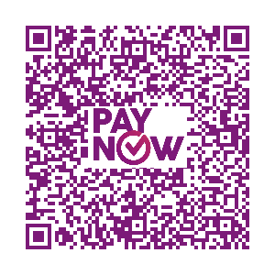  - Scan the QR code or key in UEN number 201203593ZNFL.  - Enter your mobile number in the description field.  - Fill in this form email us at nuhsfund@nuhs.edu.sg with this form attached once the transfer is made.  ☐ Cheque (Number ______________________)  Indicate your name and contact number at the back of your cheque and ensure that it is crossed and in favour of “NUHS Fund Limited”.  EVENT I/WE ARE MAKING A MONTHLY GIFT OF  $_________________________________ through  ☐ GIRO OR  ☐ Standing Instruction (Only applicable for DBS/POSB accounts)  Please download the GIRO deduction OR Standing Instruction Form via https://www.nuhs.edu.sg/Make-a-Gift/Pages/How-to-Give-a-Gift.aspx. | Name of Individual/Organisation Contact Person ☐ Dr ☐ Mr ☐ Mrs ☐ Ms  ____________________________________________________________________________________________________  Name of Organisation (Only for donations made by organisations)  ____________________________________________________________________________________________________  I require tax deduction ☐ Yes ☐ No  NRIC/ FIN/ UEN Number (Applicable if tax deduction is required, issued for donations $10  and above)  ____________________________________________________________________________________________________  Email  ____________________________________________________________________________________________________  Mobile Number (if using PayNow)  ____________________________________________________________________________________________________  Mailing Address (optional)  ____________________________________________________________________________________________________  ________________________________________________________________ Postal Code ______________________  I agree to the use of my personal data for gift processing administration and fundraising purposes by NUHS Fund, which will be strictly in accordance with NUHS’ data protection policy that is made available at https://www.nuhs.edu.sg/Pages/Personal-Data-Protection-Act.aspx.  GIFT ACKNOWLEDGEMENT (for donations $10,000 and above)  ☐ Yes, acknowledge in this name:  ____________________________________________________________________________________________________  ☐ No, I/We do not wish to be acknowledged on your donor boards.

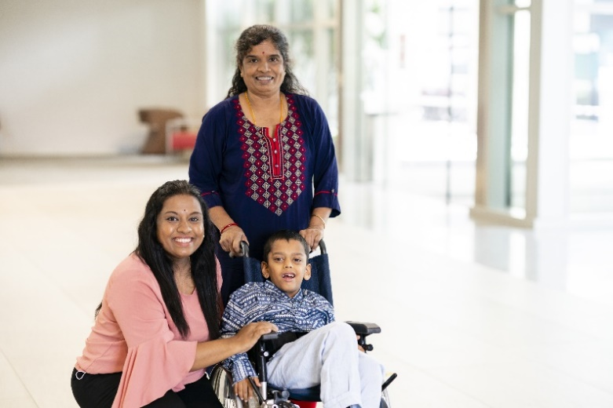
YOU can make a difference!
Born extremely premature in 2014, Thinesh is diagnosed with Dyskinetic Cerebral Palsy with Failure to Thrive. His condition causes multiple comorbidities like chronic lung disease and developmental delay.
Although both of his parents are working full time to make ends meet, the frequent check-ups and medical treatment required to manage his chronic condition have been straining his family’s finances.
Besides his medical treatments, Thinesh also received financial assistance to purchase his wheelchair. Being his main caregiver, his grandmother now finds it easier to bring him to his medical check-ups and treatments, as well as to school at the Rainbow Centre.
“Because of your generosity, we saw a glimpse of hope. He is now showing progress from his treatments.
We don’t know what we will do without your support. Thank you!” – Mother of Thinesh, Beneficiary
Fold according to this dotted line. Please do not seal with glue.
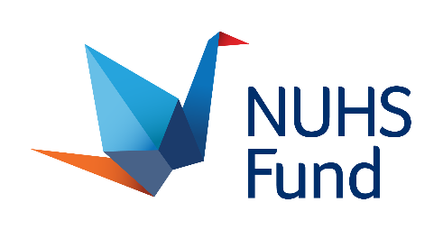
Fold according to this dotted line. Please do not seal with glue.

If you wish to find out more about NUHS Fund, please contact us at 6772 5552 or nuhsfund@nuhs.edu.sg.
www.nuhs.edu.sg/Make-a-Gift

NUHS Development Office
1E Kent Ridge Road
NUHS Tower Block, Level 13
Singapore 119228
